**Project Lifecycle Phases**

Lauren Alexandra

Colorado State University Global

CSC 501: Management for the Computer Science Professional

Dr. Charles Lively

April 16, 2021

**Introduction**

Project managers are responsible for guaranteeing a product will be delivered that meets the expectations set by the client. Any given project must have its cost, time, and resource constraints managed in such a way that the desired product quality is achieved. To accomplish this endeavor, teams depend on the leadership of the manager in addition to well prescribed procedures.

**Doing Not Consulting**

A project can not advance without the direction of a project manager. The manager collaborates with engineers and stakeholders to align on vision and priorities. Engineers design the project according to agreed upon specifications and work with the manager to mitigate risks and address technical issues as they arise. Managers *do* not *consult* with stakeholders because they are granted the authority to make decisions on project members as well as vendor and technical components (Siegel, 2019). A project manager utilizes this authority to balance competing objectives: adhering to the legally binding goals of a project while delivering on time and on budget.

**Lifecycle**

Shared project vision is achieved through accepted processes. A project may benefit from a particular lifecycle but its foundation is built on six key phases (Siegel, 2019). The client proposes a project idea which is followed by the research, development, and testing of the idea (see Figure 1). Subsequently the project is released to production and employed by its target users. These phases are continuous business operations due to an absence of a completion date but they exist within the lifecycle nonetheless (Siegel, 2019). Lastly, a project concludes with documentation,

**Figure 1**

*Project Lifecycle*

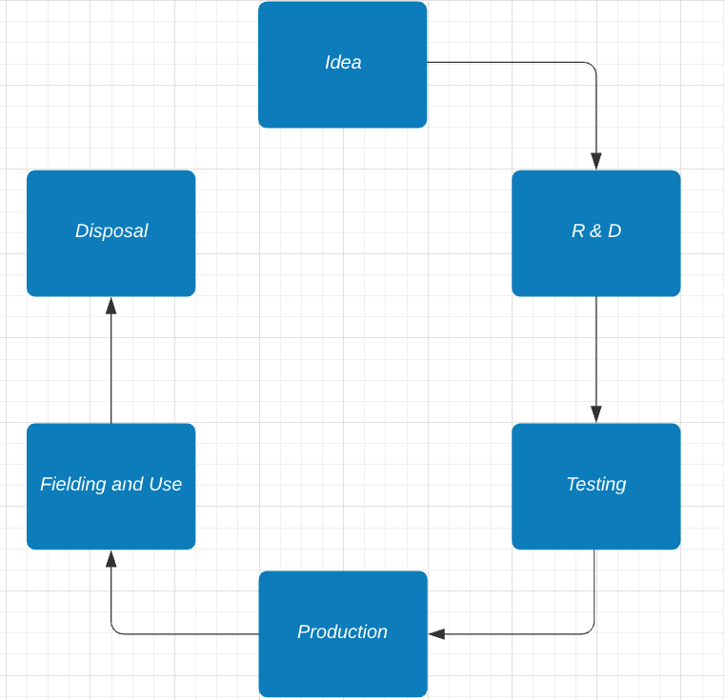

*Note.* Chart of project lifecycle phases. Created in <https://lucid.app>.

reporting and confirming the ending with project staff. These guiding steps allow for a project to be executed appropriately. A project manager can elect to implement different variations of the lifecycle--predictive, iterative, incremental, adaptive or hybrid to service the needs of the project and its members (Project Management Institute, 2017). A predictive or waterfall lifecycle maintains the scope declared at the outset. Similarly iterative lifecycles begin with scope declaration however they are updated as the team learns more about the product; product development occurs over a sequence of lifecycles. The incremental lifecycle also produces a product formed by iteration but with a designated period. Both iterative and incremental cycles fall within adaptive lifecycles which subscribe to change-driven development. Change management in the beginning phases of a project in particular can help reduce risker changes in later phases (Martinsuo & Vuorinen, 2019). If a project has fixed and flexible requirements, a hybrid approach can be utilized. Ultimately a project manager’s decision on how the product will be developed largely contributes to the success of the project (Mabelo & Sunjka, 2017).

**Conclusion**

Managers should evaluate project lifecycles within the context of a project, a company, a client, the stakeholders, and the engineering team. Lessons acquired from a team’s previous projects should inform current approaches. Through honest review, knowledge sharing and continuous collaboration, teams can improve on their project delivery.

**References**

Mabelo, P. B. & Sunjka, B. P. (2017). Application of Systems Engineering Concepts to

Enhance Project Lifecycle Methodologies. *South African Journal of Industrial*

*Engineering, 28*(3), 40-55.

Martinsuo, M. M. & Vuorinen, L. (2019). Lifecycle View of Managing Different Changes

in Projects. *International Journal of Managing Projects in Business, 12*(1),

120-143.

Project Management Institute. (2017). *A Guide to the Project Management Body of*

*Knowledge*. Project Management Institute.

Siegel, N. G. (2019). *Engineering Project Management.* John Wiley & Sons Ltd.